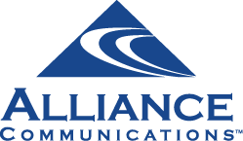
Customer Proprietary Network Information Authorization

Please Update My Account Information

Billing Name: ________________________________________________________________________________

Billing Account No:_________________________________________________________________________

I authorize Alliance Communications to allow the following person(s) to obtain information or make changes to the account(s) listed above:

 | Name (Please print) | Contact Phone Number
1
2
3
4

Above parties will need the password and/or hint answers in order to make changes to your Alliance account or to access account information.

Password to access this account: ____________________________________

Hint question 1:___________________________________________________ answer: ______________________

Hint question 2: ___________________________________________________ answer: ______________________
Examples: first pets name, favorite color, first car

Signature of account owner: __________________________________________Date: _______________________

Please retain a copy of this form for your records.
Return this form to Alliance Communications, PO Box 349, Garretson, SD 57030
If you have any questions, please contact us at 605.582.6311

